Creating a simple contact form using MySql and PHP in WAMP
(this is a project for windows OS)

Intro: WAMP stands for Windows, Apache, MySql, PHP. WAMP acts like a real
server hosting your files but is not because It’s sole purpose it for testing
webpages without internet. Read about it more on Google.

----------------------------------------------------------------

Step 1: Download and install WAMP server from http://www.wampserver.com/en/

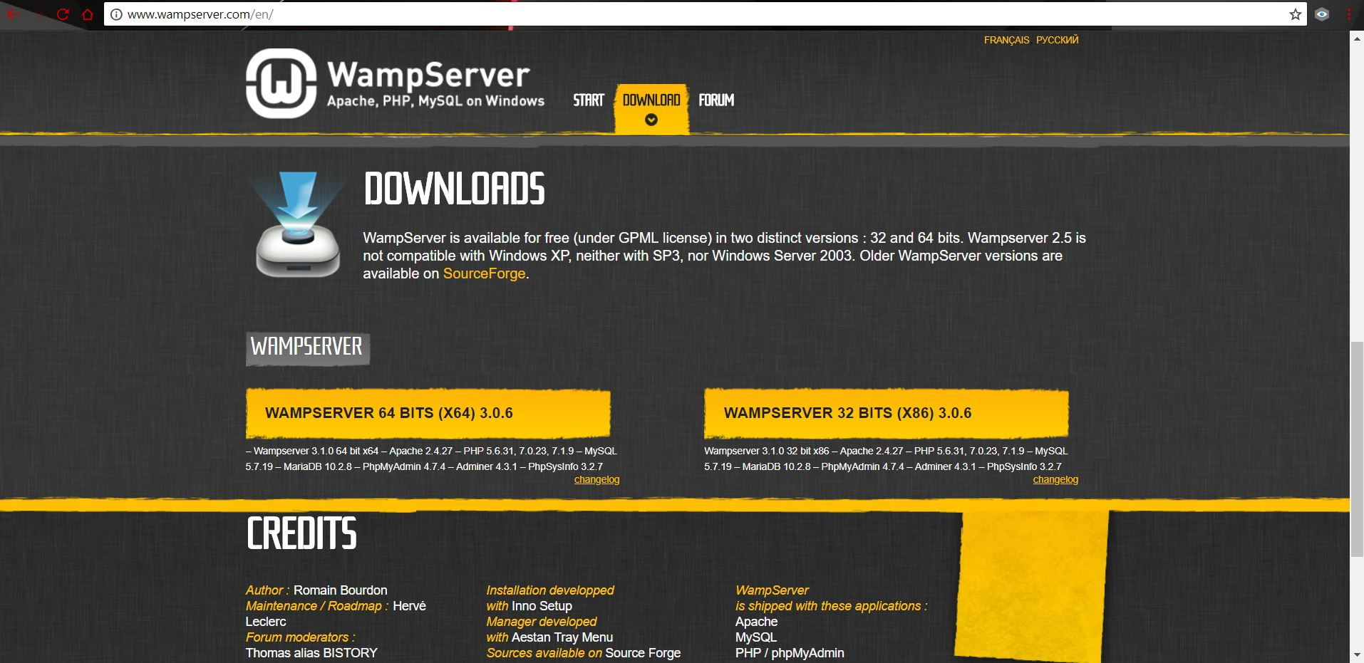
Step 2: Start WAMP from Start Menu and check if this icon appears with GREEN colour in TASKBAR here as shown, If icon is in RED or YELLOW colour, left click on the icon and click on START ALL SERVICES and then it changes to GREEN. This means that all MySql and Apache are ready to work with


* RED COLOUR:


* GREEN COLOUR:

Step 3: Go to "C:\wamp64\www" , if there are any files in here delete all of them (these files shown are to be deleted)

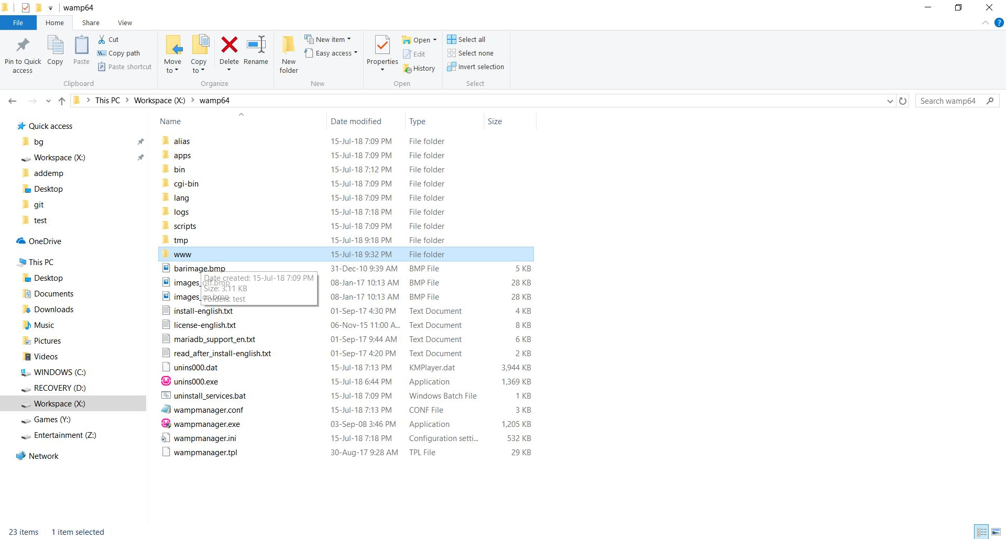

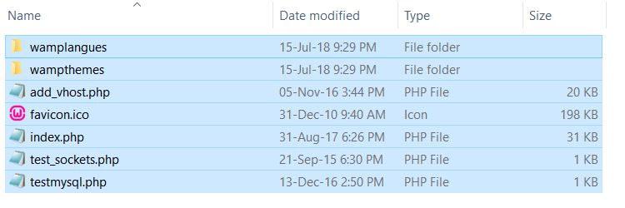

Step 4: Create a new folder named "test". Now open the folder "test" i.e. "C:\wamp64\www\test" and copy the files mentioned in this project "insert.css" and "insert.php" in this folder "test" (I have installed my WAMP in "X" local drive and don't confuse with that looking at photos usually if you haven't made any changes during installation, it will be in "C" drive)
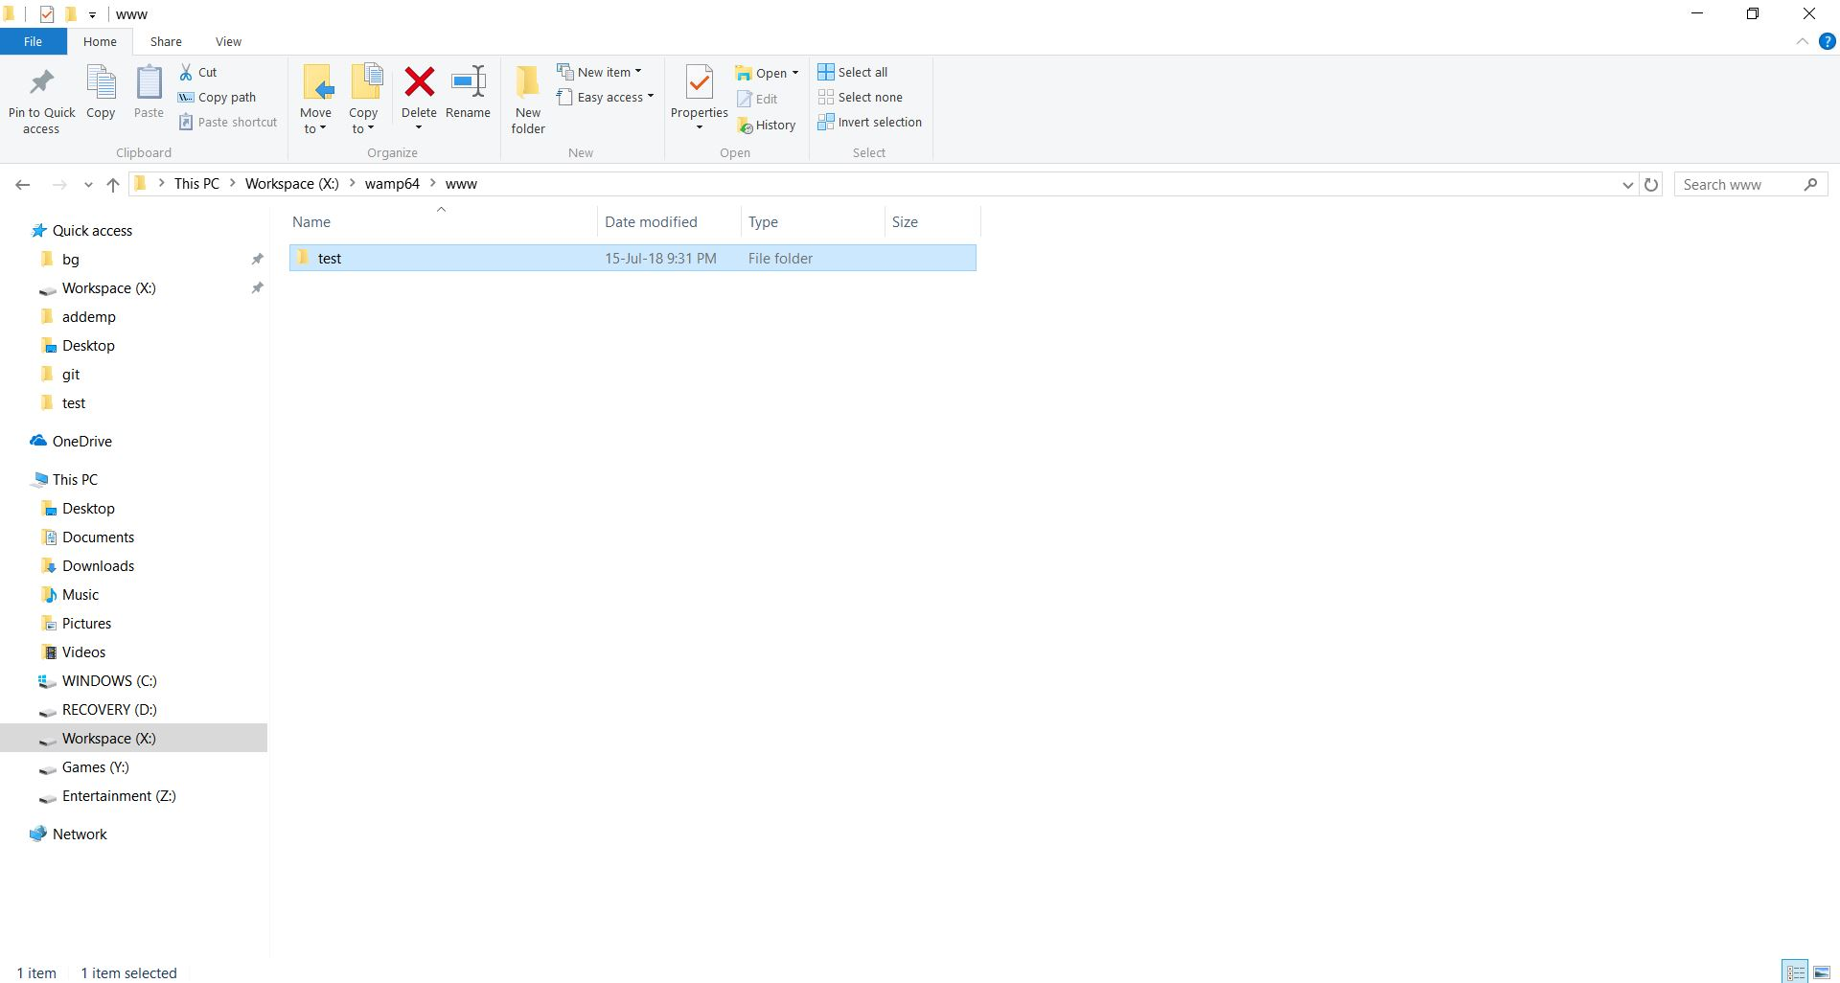

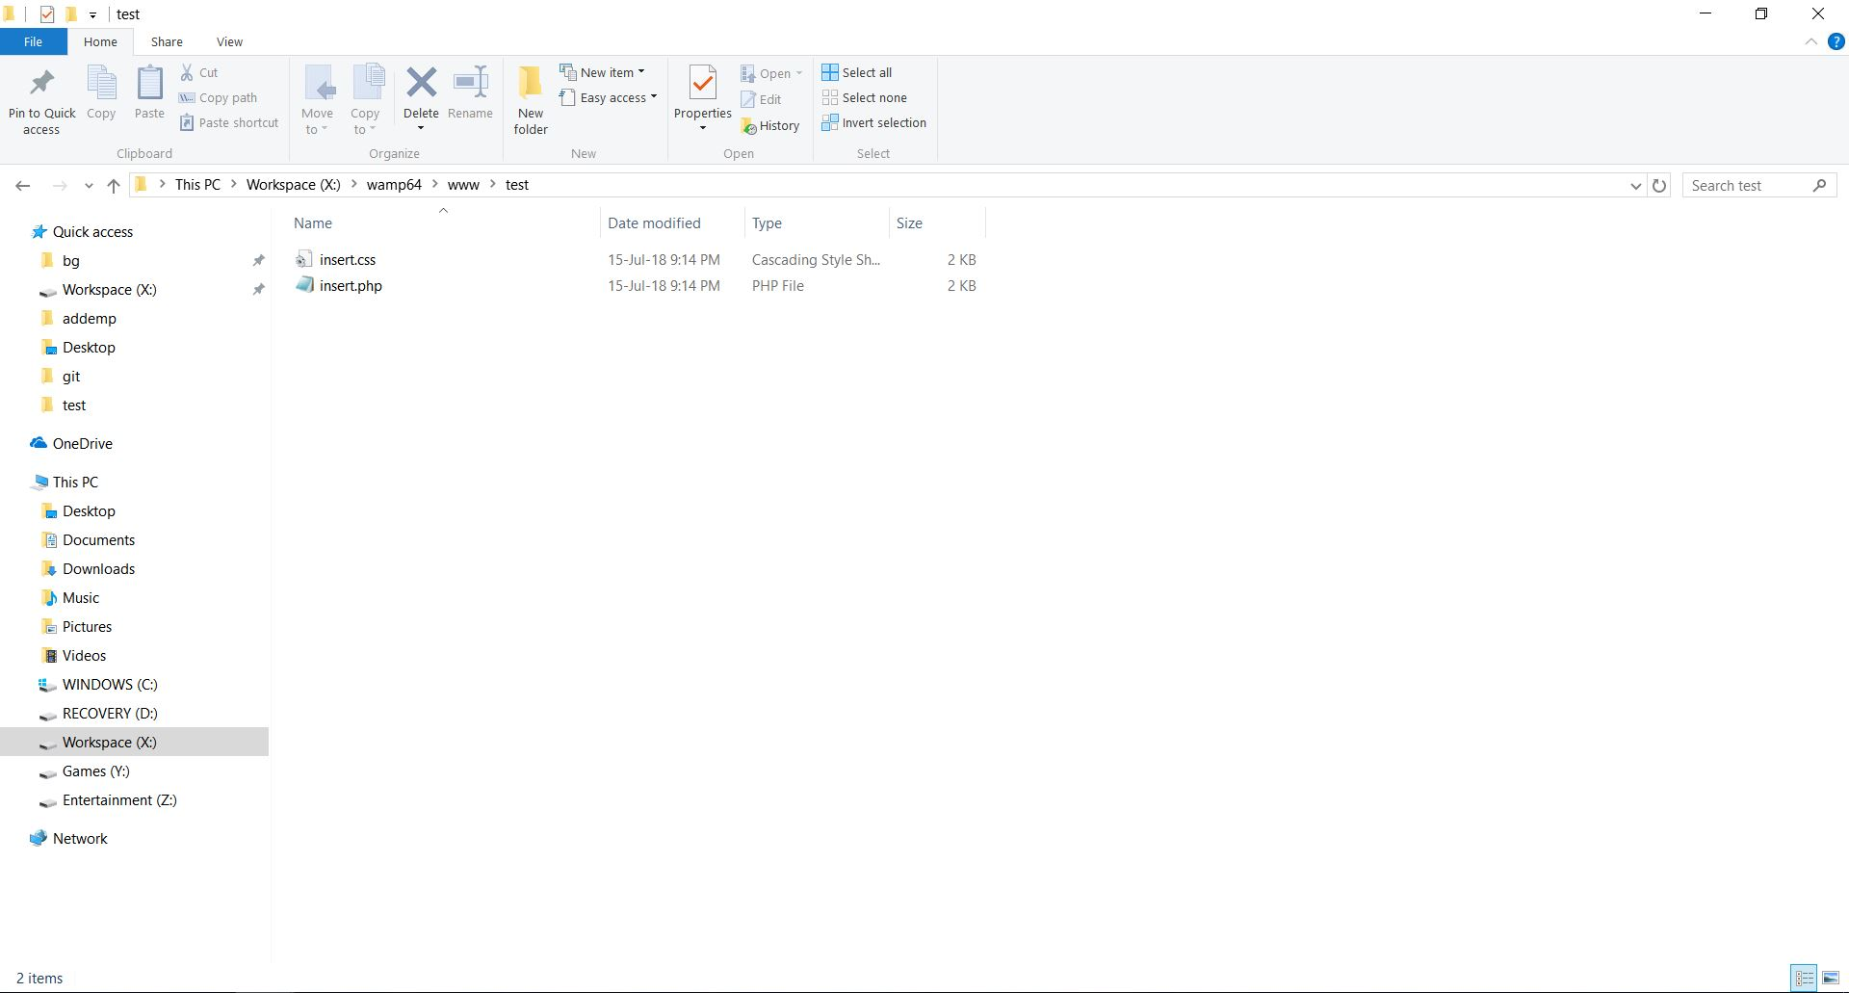
Step 5: Open the browser and type "http://localhost/phpmyadmin/index.php" in search box and enter "root" as username and keep password blank (it's default) and click on GO

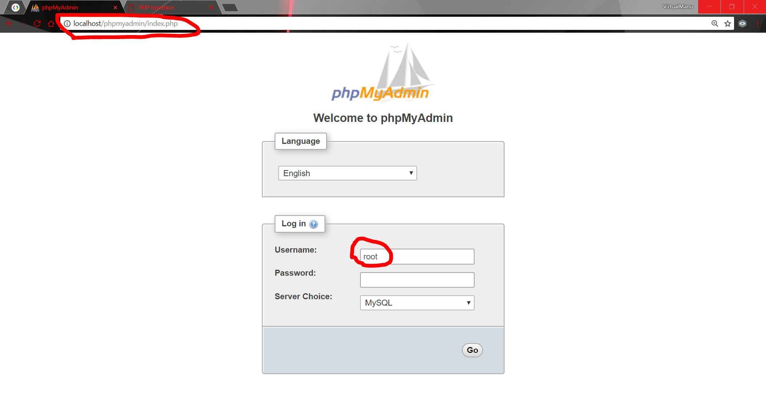
Step 6: Now click on "New", type in the name for database as "colleges" only (if you aren't modifying any code in "insert.php") and then click on create. This will create a database named as "colleges"

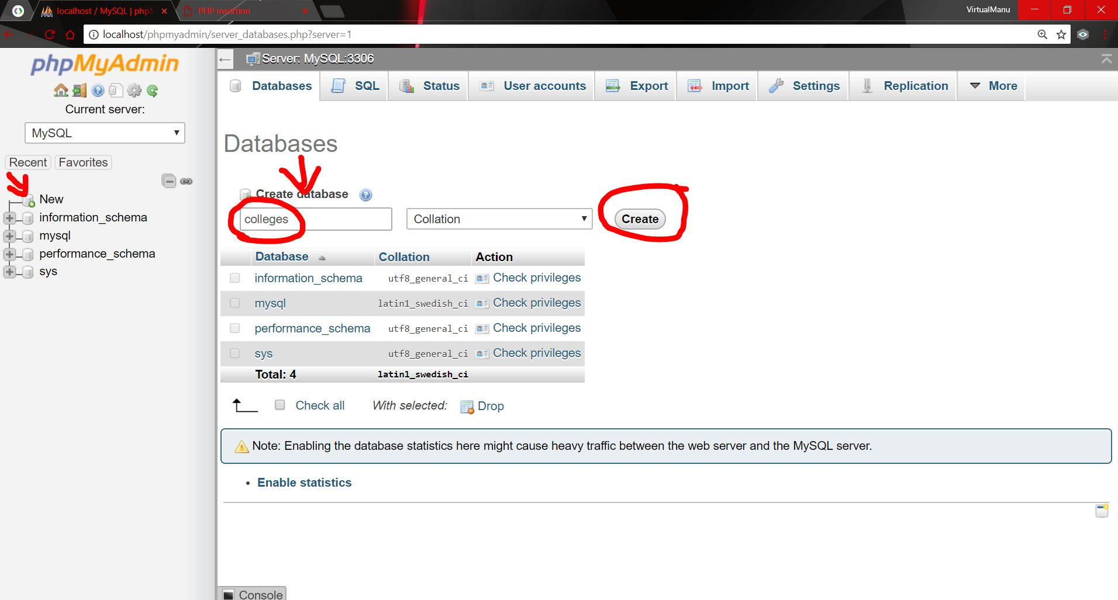

Step 7: Click on "colleges" in sidebar and click on SQL tab on top as shown in figure. Then copy and paste the code in "db.sql" file you downloaded with this project repository in the space provided as shown in fig. and click on GO. Now you've created a table named "students"

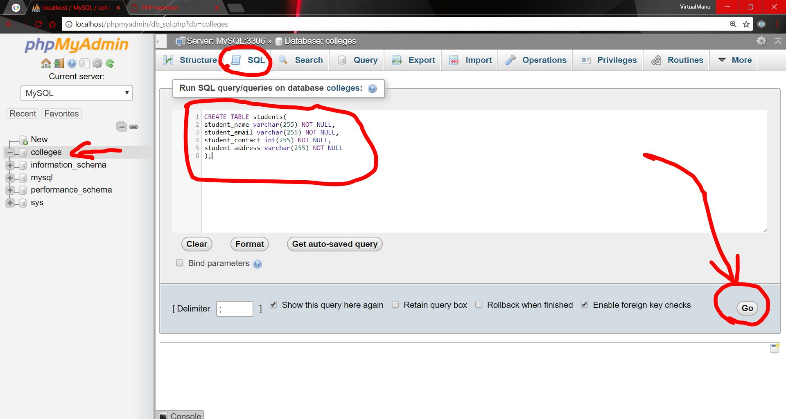
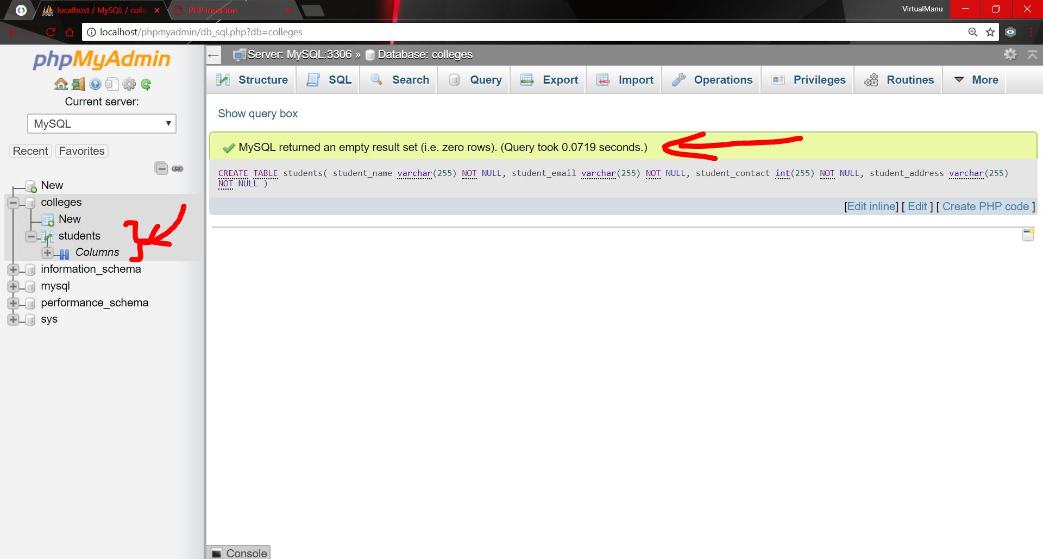
Step 8: Open a new tab on your default browser and type in "localhost" in the search and you'll get this screen, click on "test"

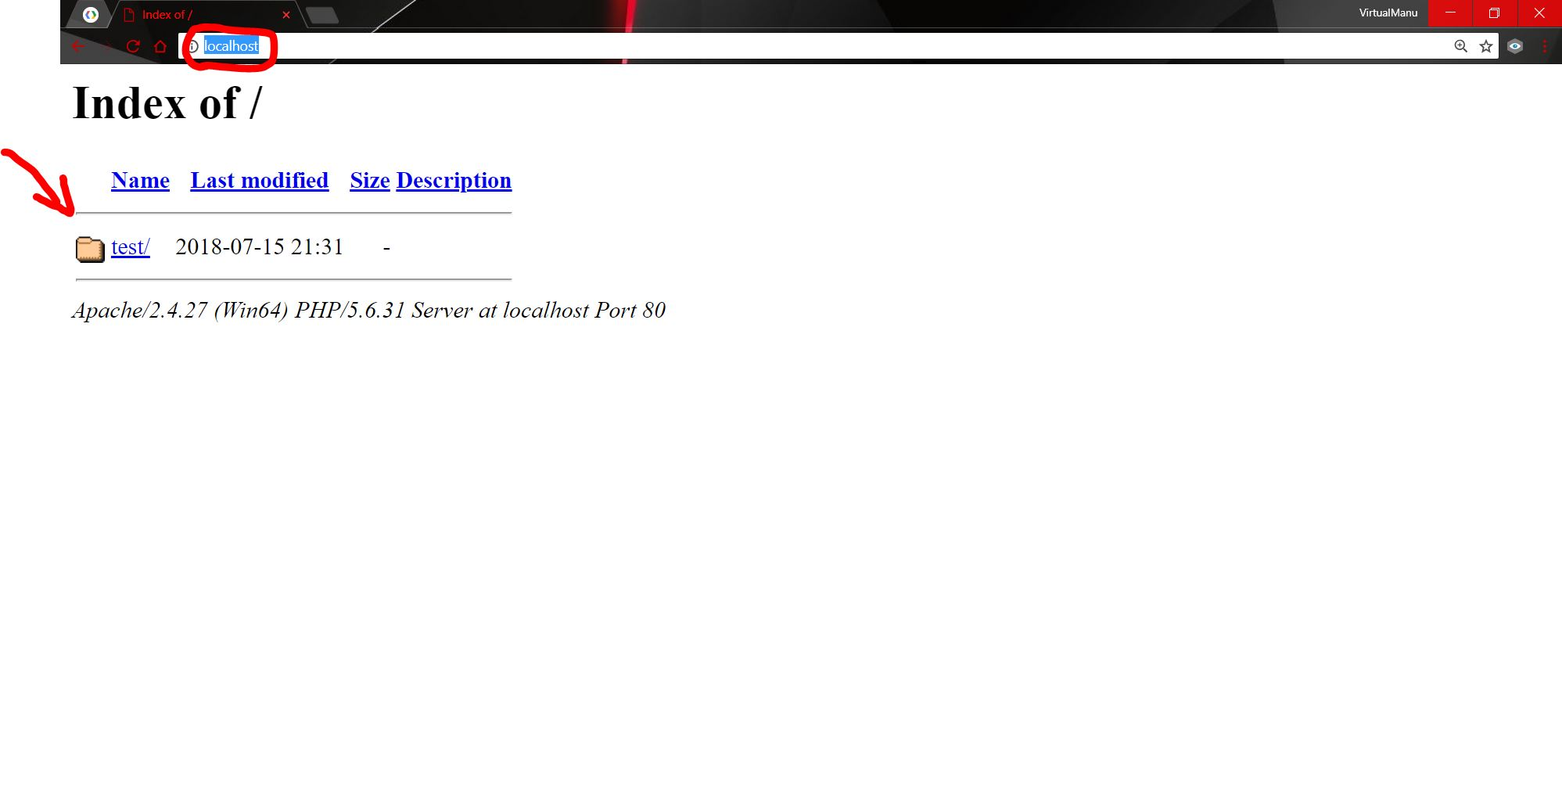
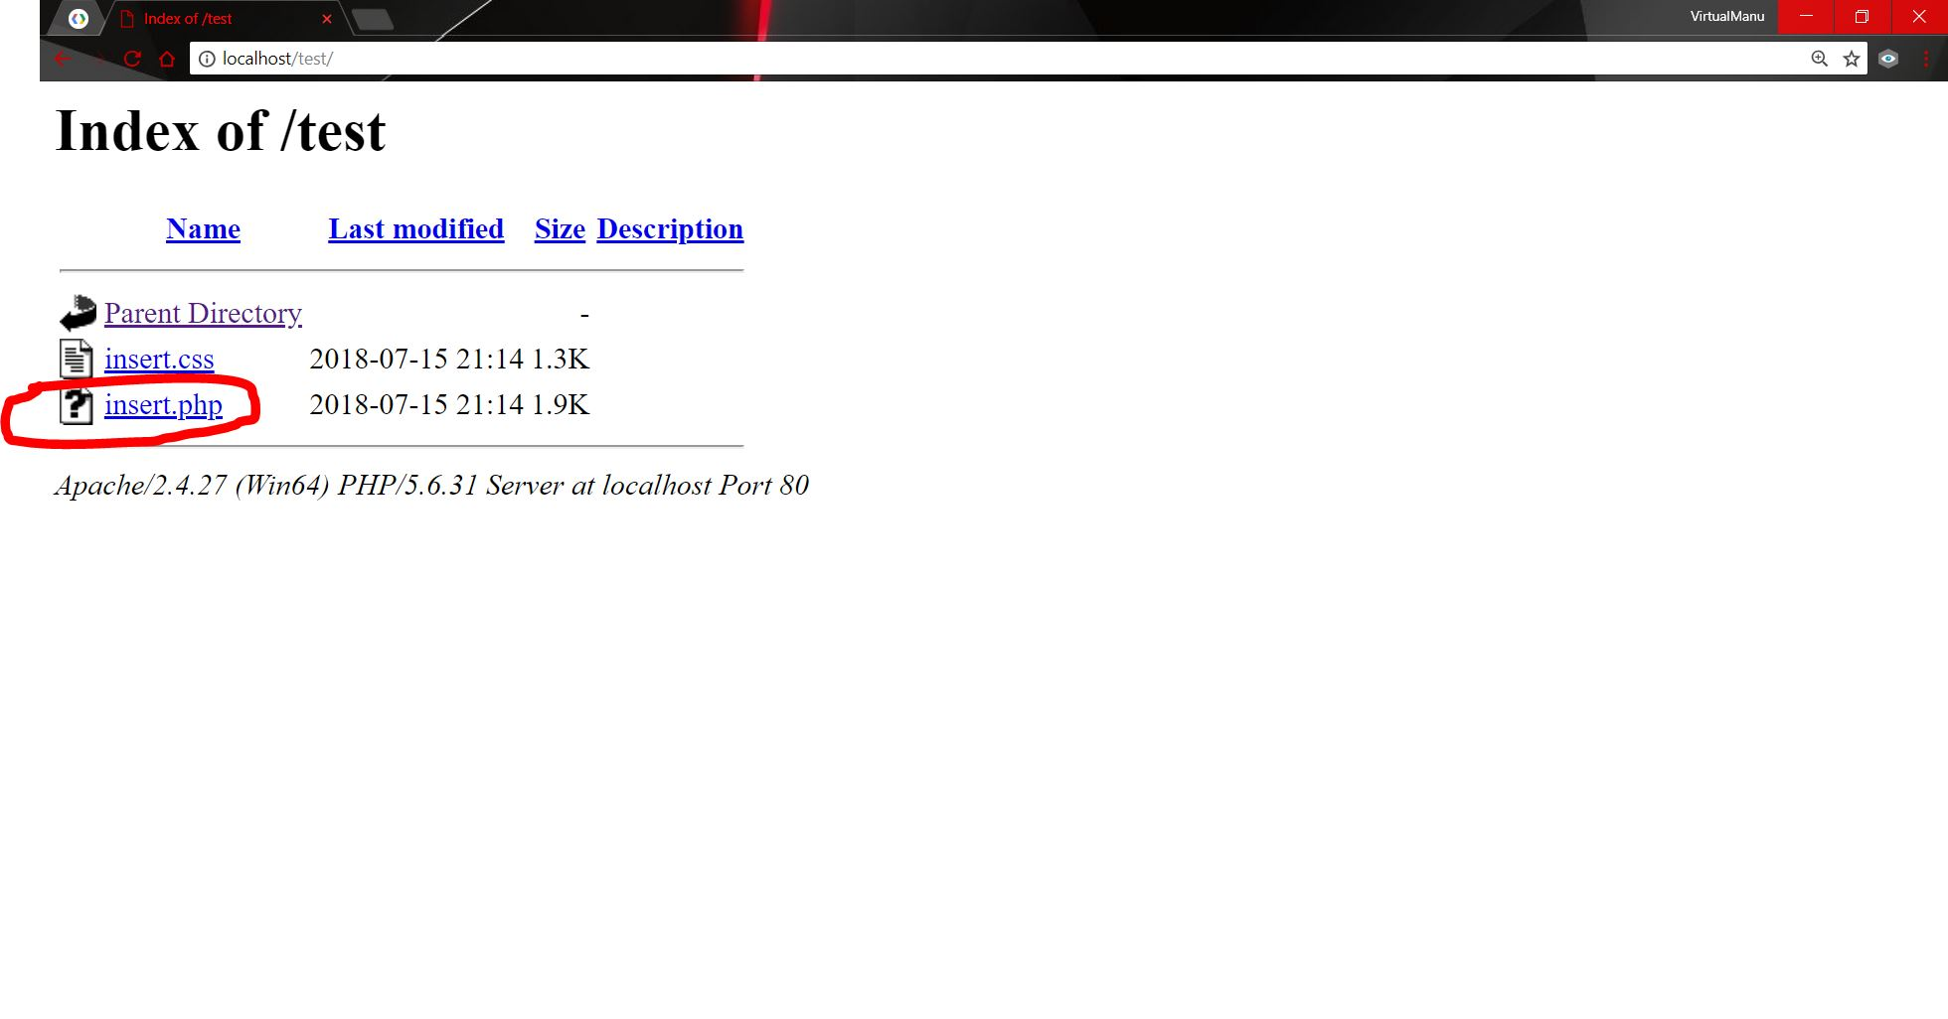

Step 9: In "test" directory click on "insert.php" then you'll get the screen like this, enter all the required information in boxes provided and click on "Insert" button

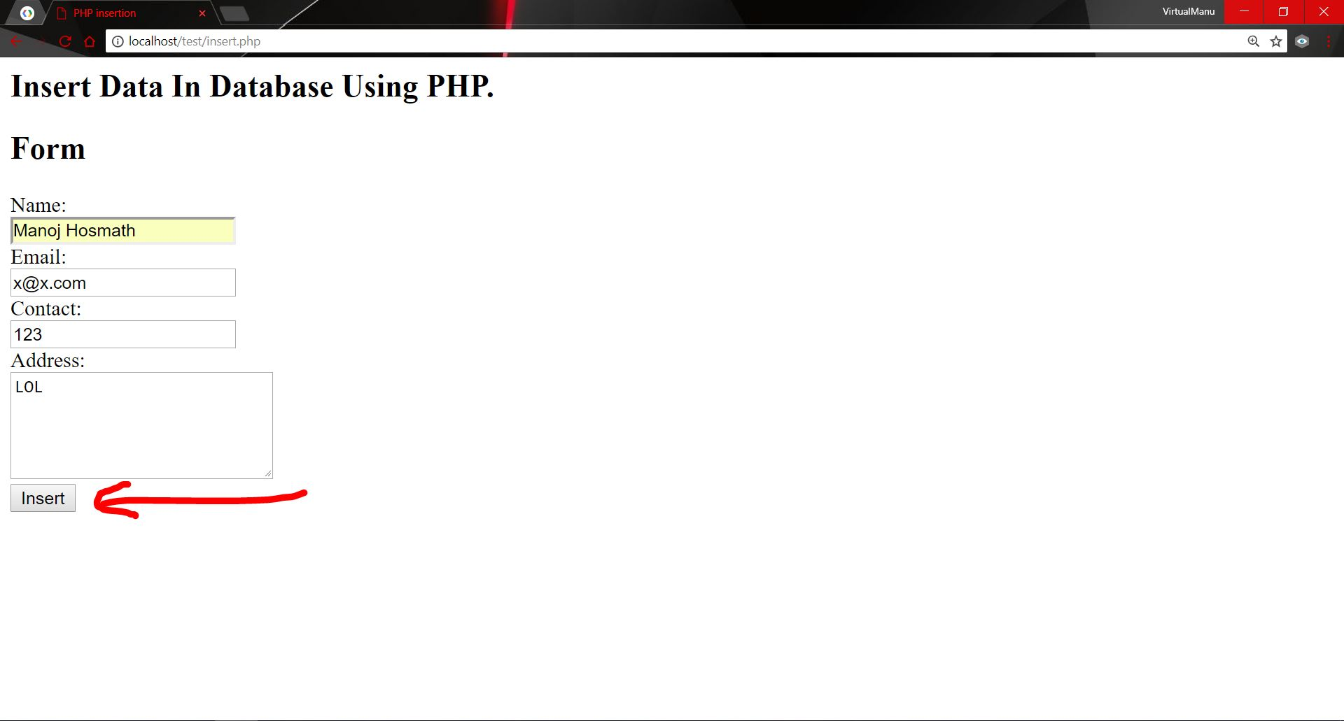
Step 10: Go back to PHPMYADMIN tab of your browser and click on "students" under "colleges' in the sidebar, you will see that your entered information is stored in SQL database. BINGO !

